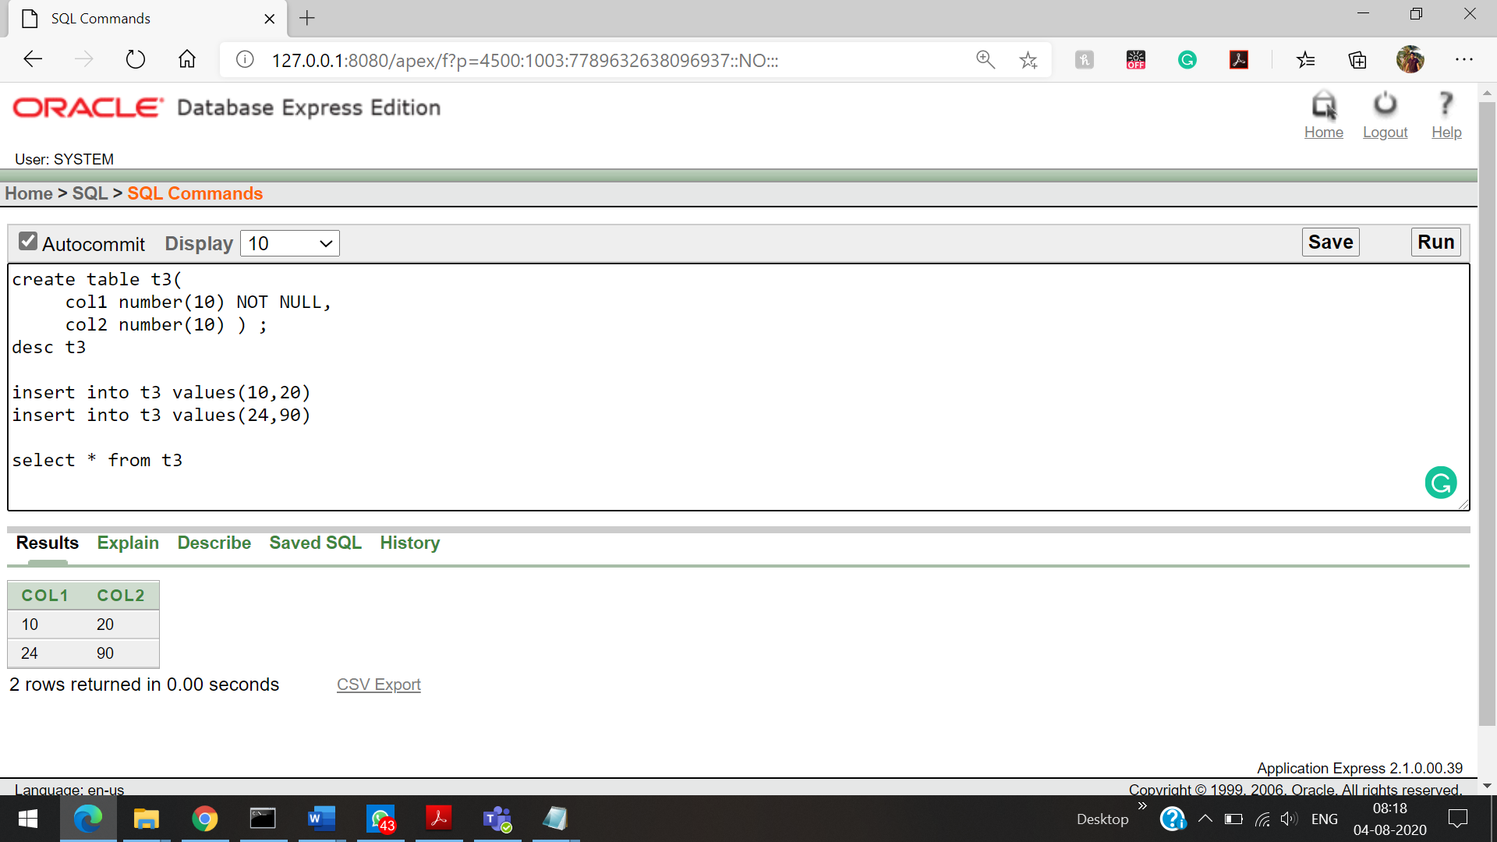

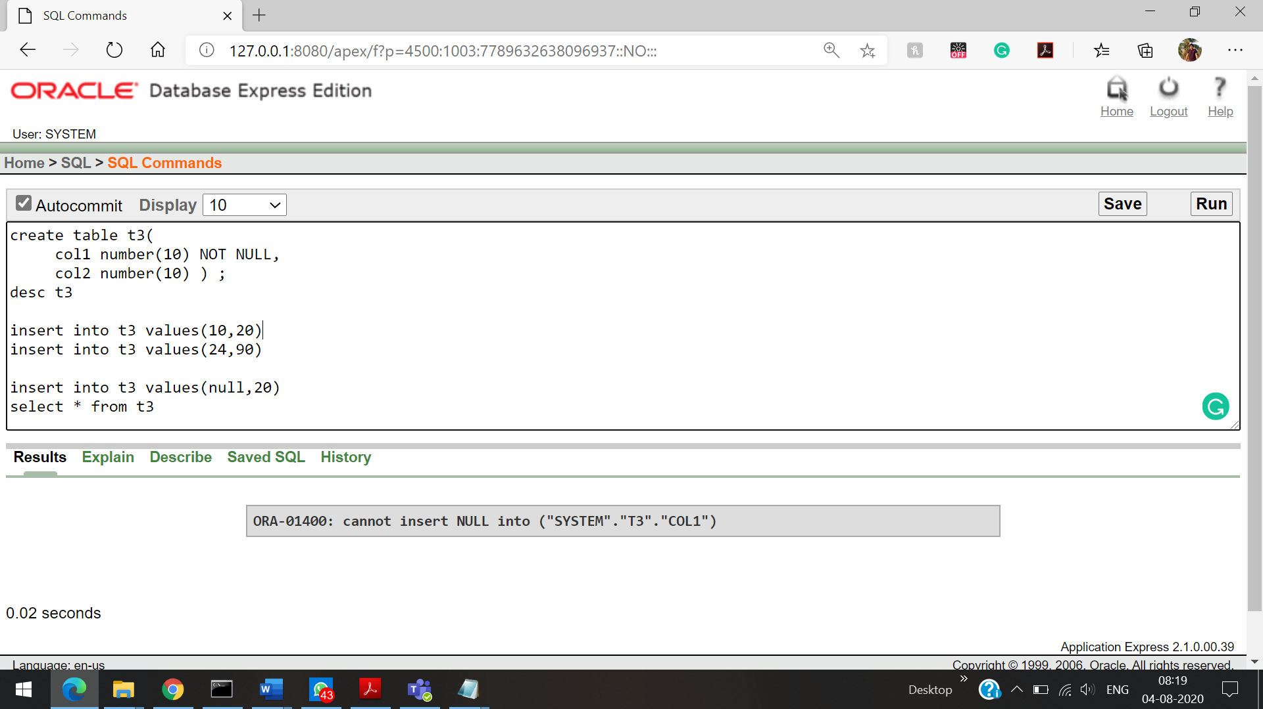

Cannot able to insert a NULL value in a not null constrain.

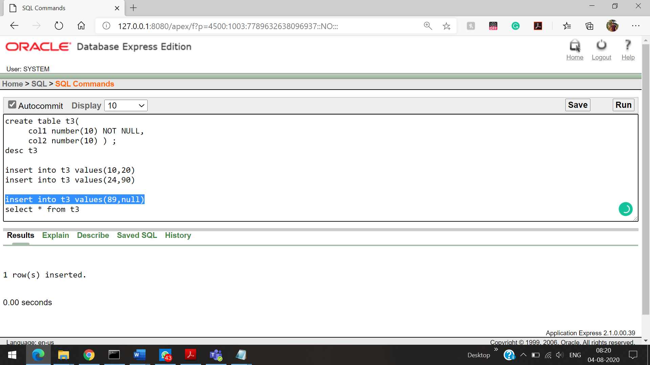

Here col1 is 🡪 Not null constrain So trying to enter a null value in col2 it accepts  
 col2 is 🡪 No not null constrain

**Not NULL Constrain**

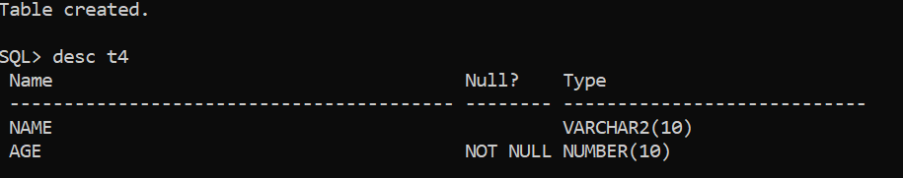

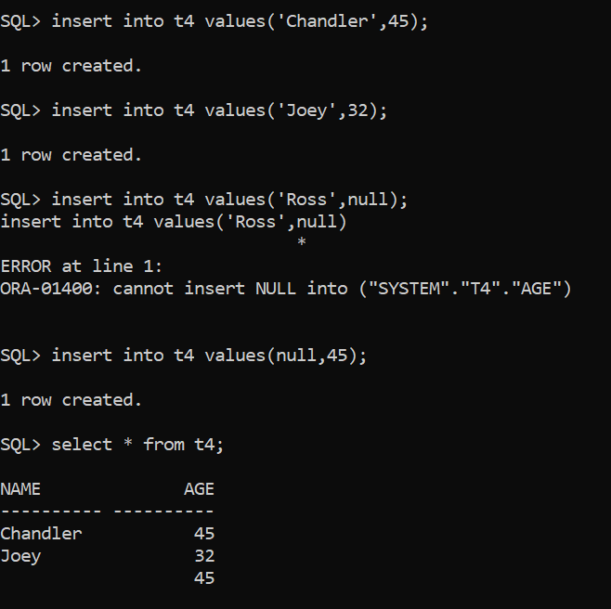



Introducing the Not NULL constrain After creating the table

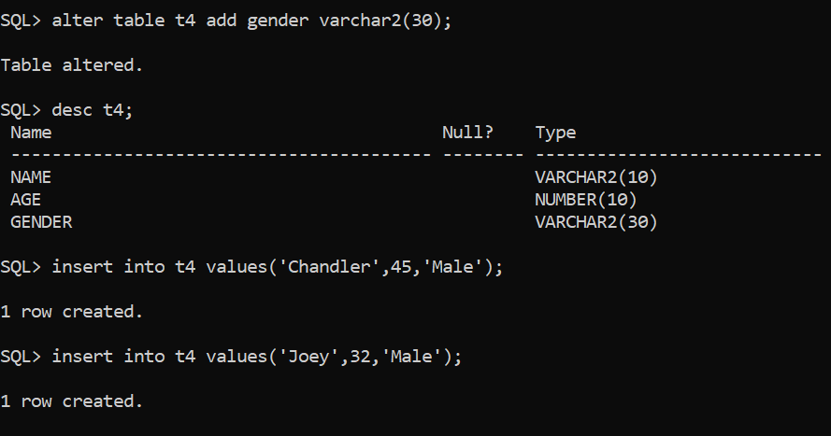

Removing the NOT NULL constrain

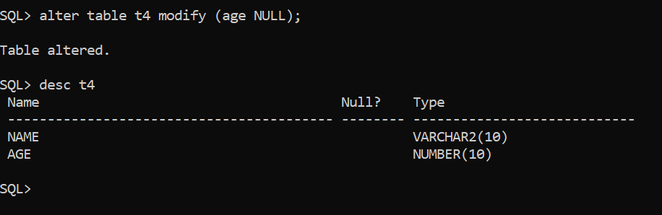

**Unique Constrain**

Creating a unique constrain while creating a table

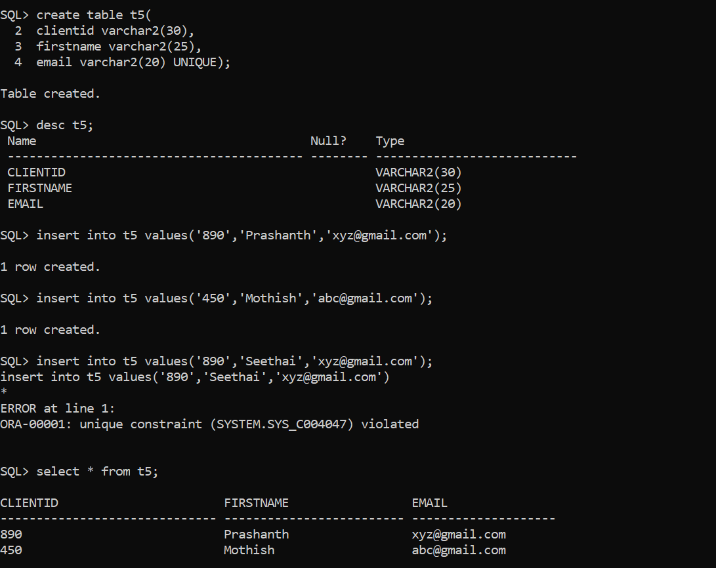

Modifying the table by adding a unique constrain

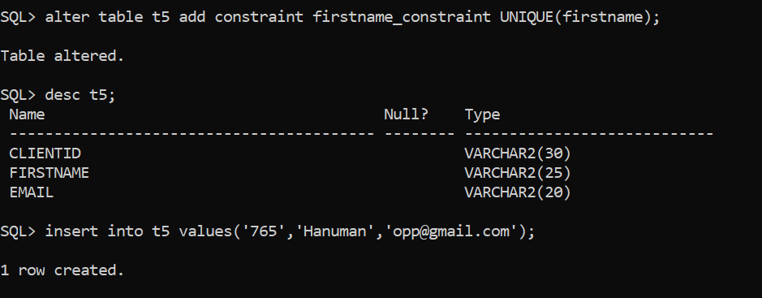

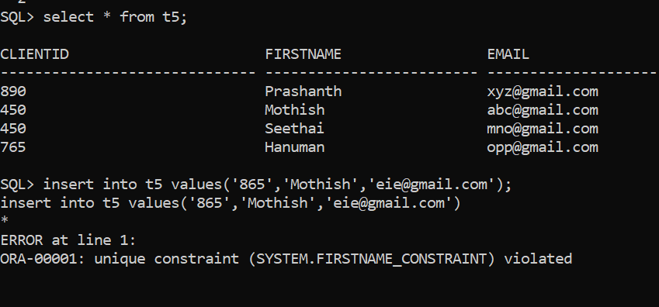



Error triggered while adding the same name in first name once again